Functional requirements

**userRegistration – priority: critical** This use case will be used by the android client and the web interface to allow new users to save their information in the database.

Use Case

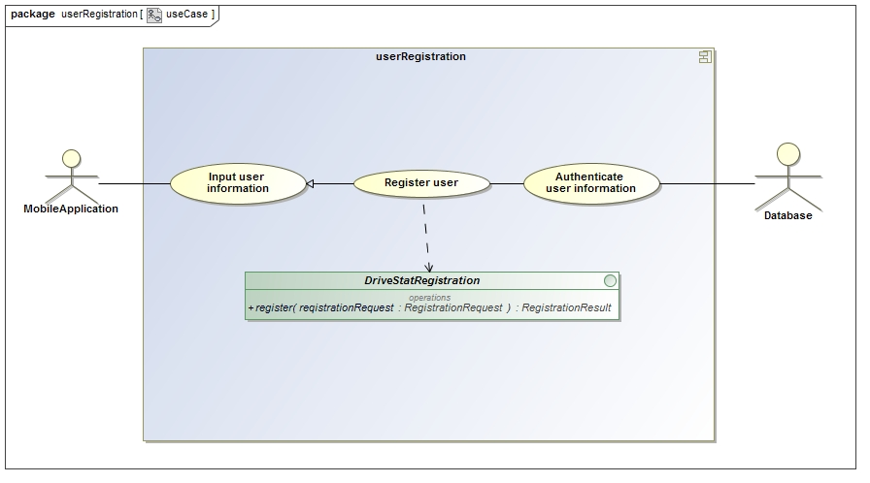

Service Contract

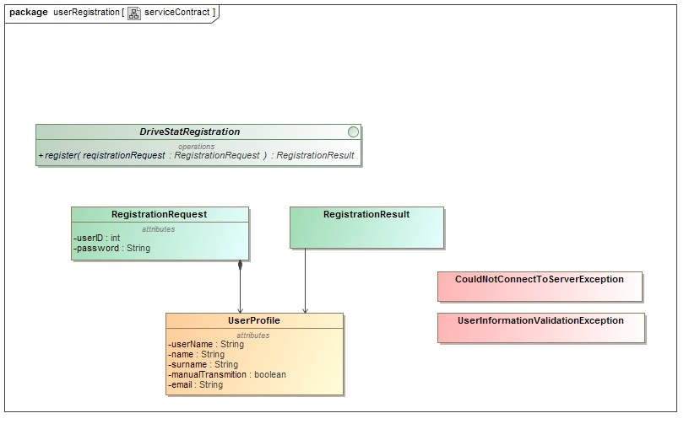

Process Specification

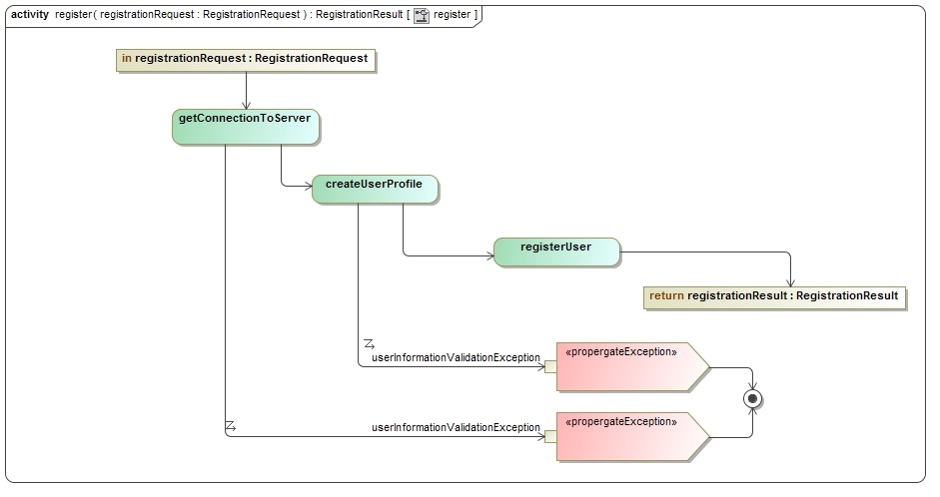

**userLogin – priority: critical** The user needs to be able to log on for a session to get a score.

Use case

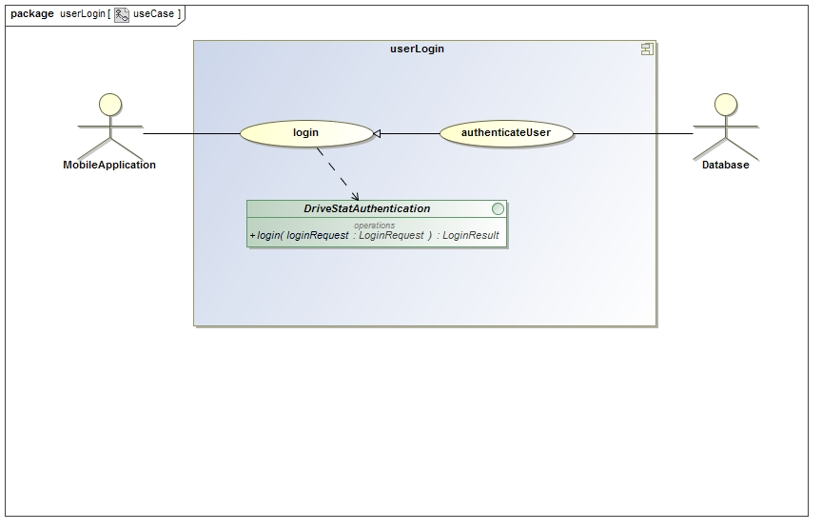

Service Contract

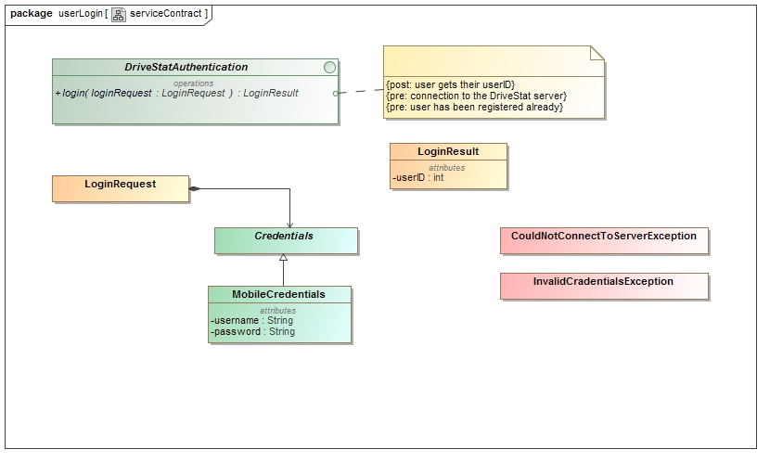

Process Specification

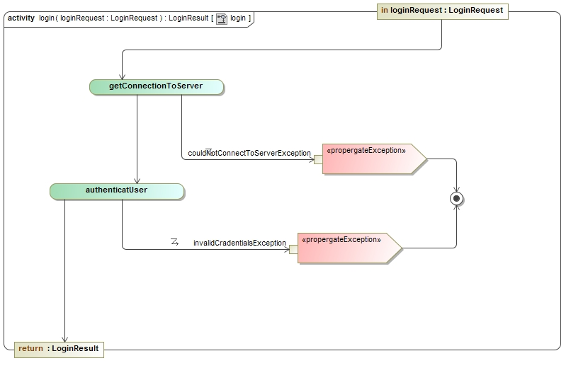

**TripMonitorState – priority: critical** This use case will be used by the user to activate and deactivate the monitoring of the phones sensors.

Use cases

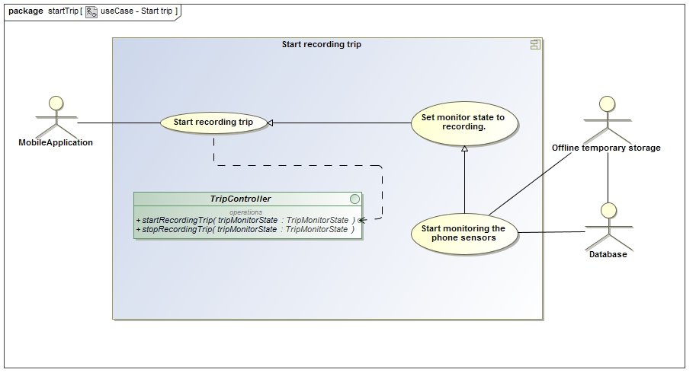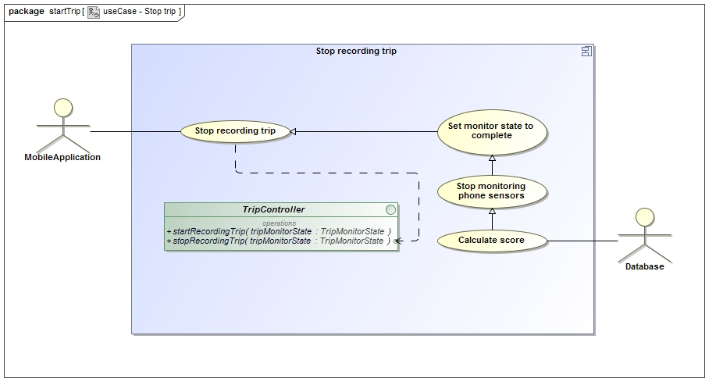

Service Contract

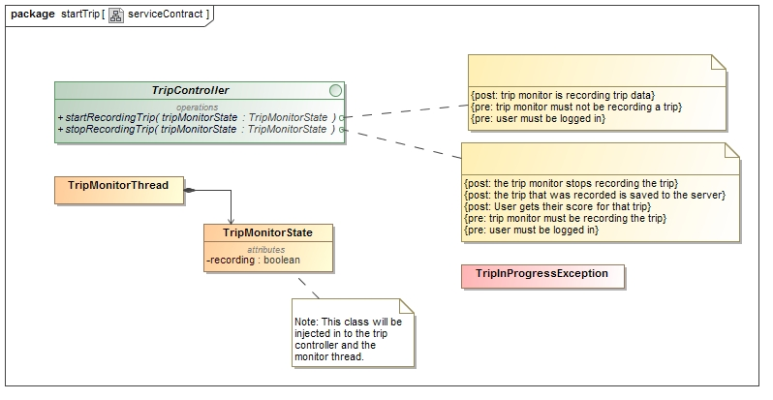

Process specification

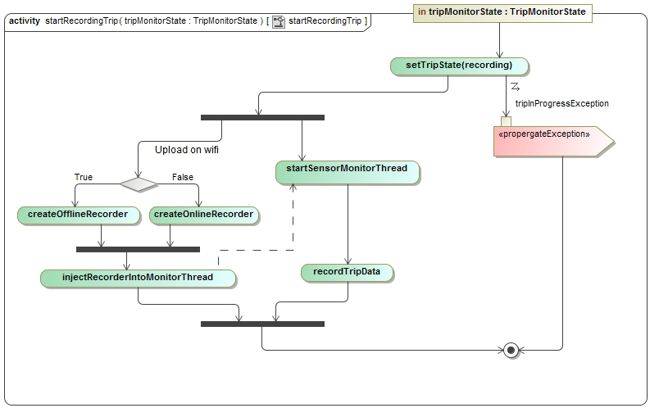

**DisplayTripInformation – priority: important** This use case will be used by the web interface to show the user the specific details and score of a trip

Use case

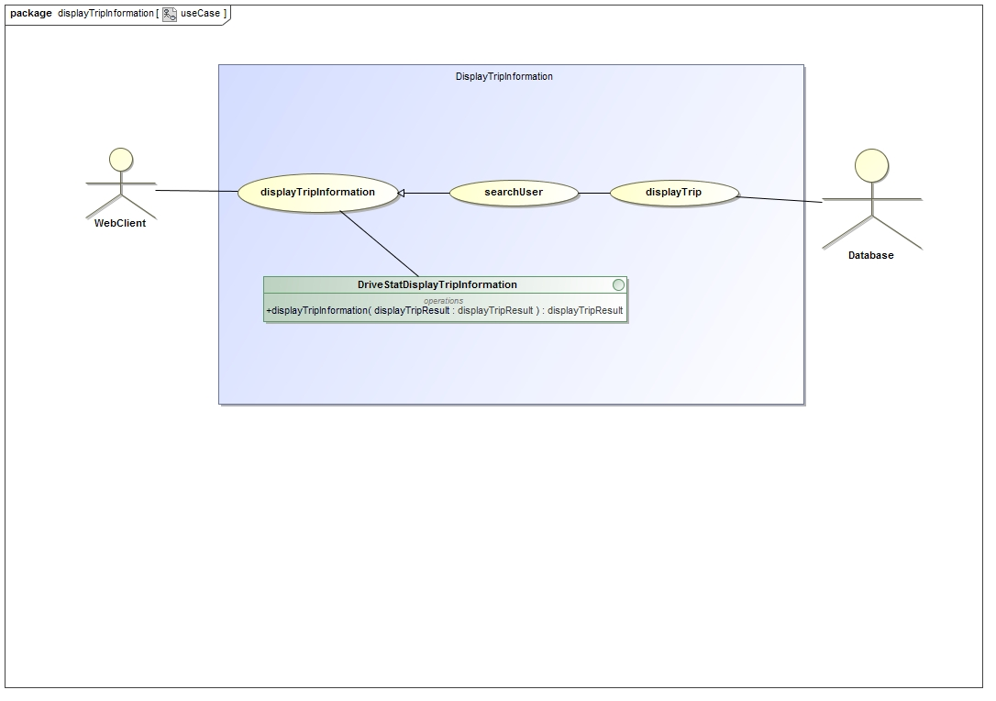

Service Contract

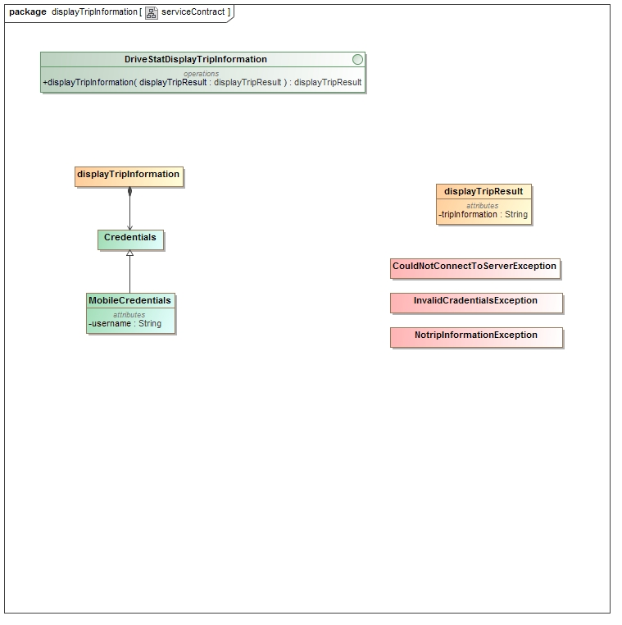

Process Specification

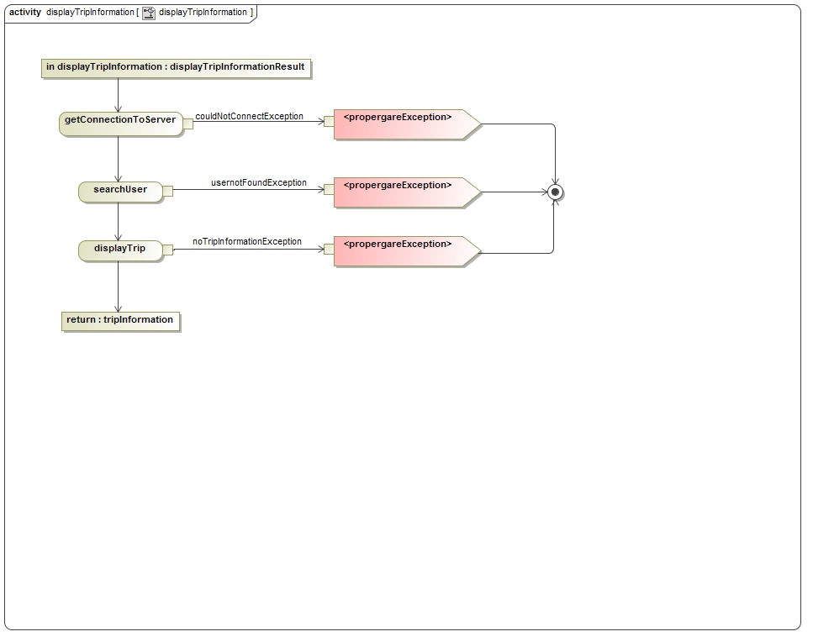

**viewComparedResults – priority: nice to have** this use case will be used by the web client to show the difference in score between users that have friended each other.

Use case

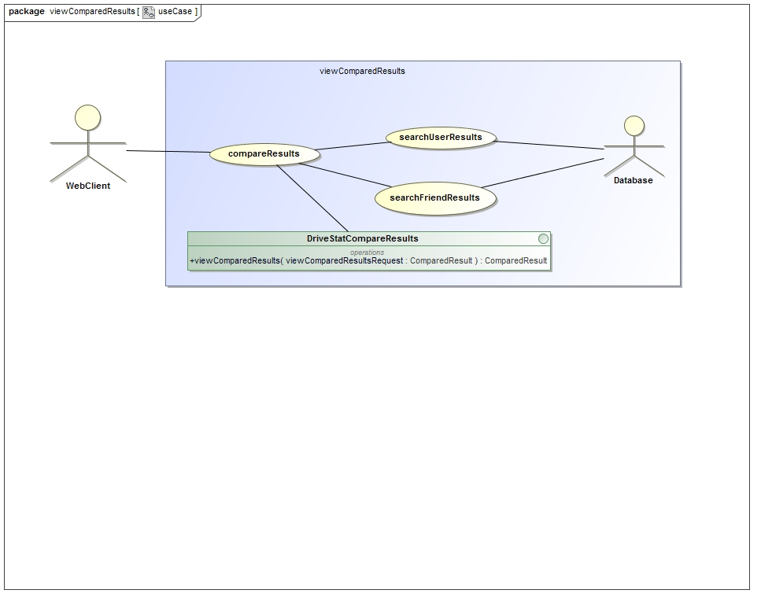

Service contract

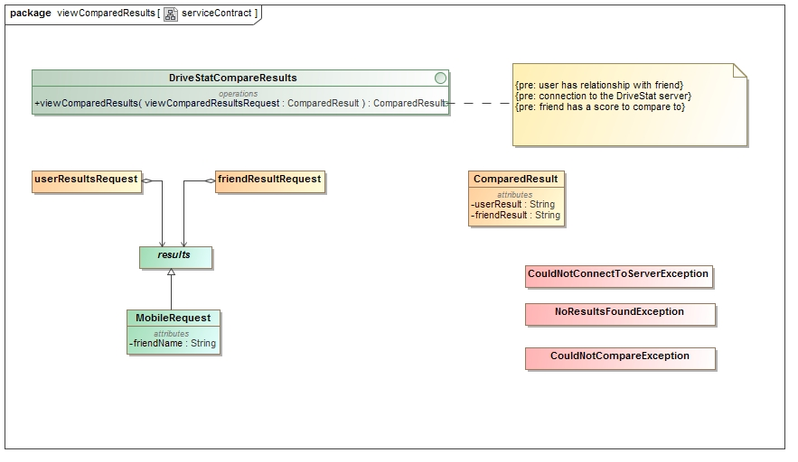

Process specification

